# Week 3: Introduction to Machine Learning (ML)

In Week 3, our focus shifts to Machine Learning (ML), a crucial subset of Artificial Intelligence (AI). We begin by defining ML and exploring its fundamental types.

## Introduction to Machine Learning (ML): A Comprehensive Exploration

Machine Learning (ML) serves as the bedrock for creating intelligent systems capable of learning and evolving from experience without explicit programming. In Week 3, our educational journey delves into the nuanced definition and diverse types of ML, unraveling the mechanisms that drive this transformative field.

Defining Machine Learning: At its core, Machine Learning empowers systems to dynamically adapt and enhance their performance based on the wealth of experiences they accumulate.

Unlike traditional programming, where explicit instructions dictate system behavior, ML relies on algorithms to analyze data, learn inherent patterns, and make predictions. This self-learning capability positions ML as a revolutionary force in enabling machines to evolve and improve over time.

<https://adamharley.com/nn_vis/mlp/3d.html>

## Types of Machine Learning

### 1. Supervised Learning

In the realm of Supervised Learning, algorithms undergo training on meticulously labeled datasets. These datasets comprise input-output pairs, essentially mapping inputs to desired outputs. The primary objective is for the algorithm to discern patterns within the labeled data so that it can accurately predict outputs for new, unseen data. Supervised Learning finds application in diverse scenarios, from predicting stock prices to recognizing handwritten characters.

### 2. Unsupervised Learning

In stark contrast, Unsupervised Learning thrusts algorithms into the realm of unlabeled data, where they grapple with extracting patterns and structure sans explicit guidance. Common tasks within Unsupervised Learning include clustering similar data points or discovering associations within datasets. This approach is particularly useful when the objective is to uncover hidden insights from raw, unstructured data. Applications range from customer segmentation in marketing to anomaly detection in cybersecurity.

### 3. Reinforcement Learning

Reinforcement Learning introduces the concept of agents navigating an environment to maximize cumulative rewards. These agents make decisions and take actions, learning from the consequences of their choices. The environment is often uncertain and complex, requiring the agent to adapt and refine its strategy over time. Reinforcement Learning has demonstrated prowess in diverse domains, from training game-playing algorithms to optimizing resource management in dynamic systems.

Delving into the intricacies of these ML paradigms offers a profound understanding of how algorithms acquire knowledge and make decisions. Supervised Learning aligns with scenarios where labeled data facilitates precise learning, while Unsupervised Learning ventures into the uncharted territories of unlabeled data, seeking inherent structures. Reinforcement Learning, on the other hand, mimics the learning process in dynamic, interactive environments.

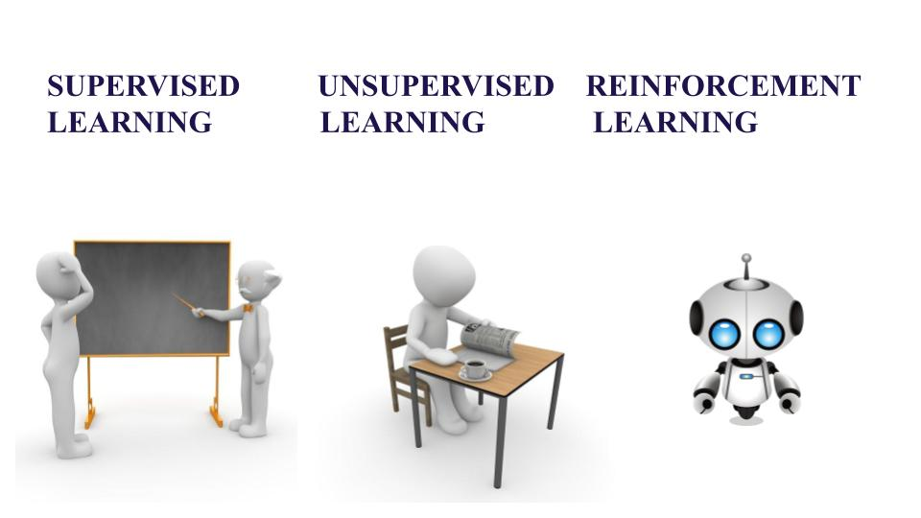

Reference: <https://www.educative.io/answers/supervised-vs-unsupervised-vs-reinforcement-learning>

### Applications and Implications

Understanding the types of ML extends beyond theoretical frameworks; it illuminates the practical applications and societal implications of these methodologies. Supervised Learning finds its way into predictive modeling for tasks like image recognition and language translation. Unsupervised Learning fuels advancements in clustering techniques, contributing to fields such as market segmentation and anomaly detection. Reinforcement Learning powers the development of intelligent systems capable of autonomous decision-making, revolutionizing fields like robotics and autonomous vehicles.

As the applications expand, ethical considerations become paramount. Issues of bias, transparency, and accountability surface, necessitating a holistic approach to the development and deployment of ML systems. Ensuring fairness and mitigating biases are critical, especially when these systems impact individuals and communities. The ethical dimension in ML underscores the importance of responsible AI practices to avoid perpetuating societal inequities.

Detecting Fraud using ML: <https://www.forbes.com/sites/forbestechcouncil/2023/11/01/how-ai-and-machine-learning-help-detect-and-prevent-fraud/?sh=45bfc18376d2>

### Emerging Trends and Future Prospects

The landscape of Machine Learning is dynamic, with constant evolution and innovation. Emerging trends promise to shape the future of ML, influencing industries, research, and societal norms. As algorithms become more sophisticated, the fusion of ML with other technologies, such as edge computing and the Internet of Things (IoT), opens new frontiers.

One notable trend is the growing focus on Explainable AI (XAI), addressing the interpretability of ML models. As ML systems penetrate critical domains like healthcare and finance, the ability to explain decisions becomes crucial for gaining user trust and ensuring regulatory compliance. Research and development efforts in XAI aim to demystify the decision-making processes of complex ML models, enhancing transparency and accountability.

The integration of ML with Big Data analytics amplifies the potential for extracting meaningful insights from vast datasets. This synergy enables businesses and researchers to glean actionable intelligence, driving informed decision-making. The ongoing synergy between ML and Big Data stands as a testament to the collaborative nature of technological advancements.

## Data Processing in Machine Learning

In the expansive realm of Machine Learning (ML), grasping fundamental concepts is pivotal for unlocking the full potential of intelligent systems. As we delve into Week 3, our focus shifts to essential ML concepts: Features, Training, Testing, and Validation. Unraveling these intricacies not only lays the groundwork for building robust ML models but also illuminates the critical role they play in shaping real-world applications.

### Features

The Essence of ML Input: At the heart of any ML model lie its features, the variables or attributes drawn from the data that serve as inputs for the algorithm. Features encapsulate the relevant information that the model uses to make predictions or decisions. These can range from numerical values like temperature and age to categorical variables like gender or product type. The process of feature engineering involves selecting, transforming, or creating new features to enhance the model's predictive performance.

### Feature engineering

an art as much as a science, demands a deep understanding of the data and the problem at hand. Crafting meaningful features can significantly impact the model's ability to discern patterns and relationships within the data. This nuanced process often involves transforming raw data into a format that amplifies the signal and minimizes noise, ultimately refining the model's predictive accuracy.

### Training

Nurturing Algorithms to Learn: The training phase is the crucible where ML algorithms undergo a transformative journey. In this stage, the algorithm learns from historical data to make predictions on new, unseen data. The dataset used for this purpose is aptly named the training dataset. Each entry in this dataset comprises both input features and the corresponding desired output, guiding the algorithm to discern patterns and relationships.

During training, the algorithm adjusts its internal parameters, effectively learning the mapping between input features and output. This adaptive process equips the model to generalize its learning beyond the training data, making accurate predictions on new, previously unseen data. The efficacy of the training process is paramount, as it directly influences the model's ability to make informed decisions in real-world scenarios.

### Testing

Assessing Real-World Efficacy: The true measure of an ML model's prowess lies in its performance on unseen data, a scenario it has not encountered during training. Enter the testing phase, where the model is rigorously evaluated on a dataset separate from the one used for training—the test dataset. This separation ensures that the model's capabilities extend beyond memorization of the training data, demonstrating its adaptability and generalization.

Evaluating a model on the test dataset illuminates its real-world efficacy, shedding light on its ability to make accurate predictions in diverse scenarios. Common metrics employed for this assessment vary based on the nature of the ML task. For instance, regression tasks may use metrics like Mean Absolute Error (MAE) or Mean Squared Error (MSE), while classification tasks may rely on accuracy, precision, recall, and the Area Under the Receiver Operating Characteristic Curve (AUC-ROC).

### Validation

Fine-Tuning for Optimal Performance: In the intricate dance of ML model development, overfitting poses a lurking challenge. Overfitting occurs when a model learns the training data too closely, capturing noise and outliers that are specific to that dataset but do not generalize well to new data. To mitigate this risk, a dedicated portion of the data—the validation dataset—is set aside.

The validation dataset serves a dual purpose. First, it aids in fine-tuning the model's parameters. By iteratively adjusting the model based on its performance on the validation data, practitioners prevent overfitting and enhance the model's ability to generalize. Second, the validation dataset acts as a checkpoint for assessing the model's performance during development, providing insights into potential areas for improvement.

Effectively navigating the delicate balance between training, testing, and validation is an art that defines the success of ML models. It involves iterative refinement, where insights gained from testing and validation guide adjustments to the model, ensuring that it not only learns from the training data but can also adeptly handle new, unseen challenges.

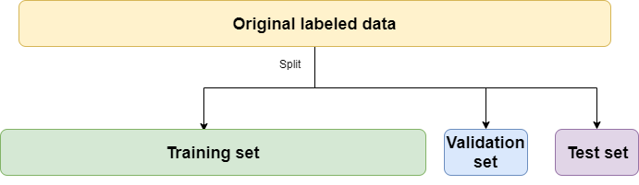

### Applications and Significance

Understanding these foundational concepts extends beyond theoretical comprehension—it directly influences the practical application of ML in diverse domains. Robust feature engineering is the linchpin for models in fields ranging from finance, where predicting stock prices demands a nuanced understanding of market indicators, to healthcare, where patient outcomes hinge on a multitude of variables.

The training and testing phases find application in scenarios as varied as natural language processing, image recognition, and autonomous vehicle navigation. These phases are the crucibles where models learn to understand the complexities of language, recognize patterns in images, and navigate dynamic environments.

Validation, often an unsung hero, plays a pivotal role in ensuring that ML models not only excel in training and testing scenarios but also generalize well to unforeseen situations. It acts as a compass, guiding practitioners in the development journey, steering them away from the pitfalls of overfitting and towards models that robustly capture the essence of the data.

### Challenges and Future Perspectives

While these concepts form the bedrock of ML, challenges persist. The dynamic nature of real-world data, the need for continuous adaptation, and the quest for models that can comprehend the subtleties of human cognition pose ongoing challenges. The future holds promises of automated feature engineering, more sophisticated training algorithms, and techniques for improving model interpretability.

The intersection of ML with other emerging technologies, such as Explainable AI (XAI) and Federated Learning, further expands the horizons. XAI addresses the black-box nature of some ML models, aiming to make their decision-making processes more transparent and interpretable. Federated Learning, on the other hand, enables model training across decentralized devices without exchanging raw data, opening avenues for privacy-preserving collaborative learning.

## Regression, Classification, and Clustering Algorithms

In the expansive universe of Machine Learning (ML), understanding the diverse array of algorithms is paramount for harnessing the true potential of intelligent systems. As we embark on this journey, Week 3 unfolds with a focus on the fundamental algorithms that underpin ML applications: Regression, Classification, and Clustering. These algorithms, each with its unique characteristics and applications, form the backbone of predictive modeling, decision-making, and data exploration.

### Regression

Predicting the Continuous Tapestry of Values: At the heart of regression lies the task of predicting continuous values. In practical terms, this involves foreseeing outcomes that exist on a spectrum, such as predicting house prices, stock values, or temperature fluctuations. Linear Regression, an emblematic algorithm in this domain, serves as a guiding light.

Linear Regression operates on the premise of establishing a linear relationship between input features and the continuous output. For instance, in predicting house prices, the algorithm seeks to delineate how changes in features like square footage, location, or the number of bedrooms correlate with the property's price. By fitting a line through the data points, the algorithm creates a model that can extrapolate and predict house prices for new, unseen data.

Beyond Linear Regression, advanced techniques such as Ridge Regression introduce regularization to mitigate overfitting, ensuring the model's adaptability to a broader range of scenarios. The regression landscape, continually evolving, spans from predicting financial market trends to estimating future healthcare costs, showcasing its versatility in real-world applications.

### Classification

Deciphering Categorical Conundrums: In the tapestry of ML algorithms, Classification emerges as a key thread, unraveling the mysteries of predicting categorical outcomes. Instead of continuous values, the focus here is on discerning and assigning data points to predefined categories. Logistic Regression, a stalwart in the classification realm, takes center stage.

Consider the scenario of classifying emails as spam or not spam—a quintessential classification task. Logistic Regression navigates this terrain by employing a logistic function to model the probability of an email belonging to either category. The algorithm learns from labeled data, adjusting its parameters to create a decision boundary that effectively separates spam from non-spam emails.

Beyond Logistic Regression, decision trees and support vector machines (SVMs) expand the repertoire of classification algorithms. Decision trees, with their intuitive branching logic, excel in scenarios like credit scoring, where the goal is to categorize individuals into creditworthy and non-creditworthy groups. SVMs, on the other hand, carve optimal hyperplanes in high-dimensional spaces, making them effective in image recognition and medical diagnosis.

### Clustering

Unveiling Patterns in Data Diversity: As we navigate the rich tapestry of ML algorithms, the realm of Clustering emerges as a captivating landscape. Unlike regression and classification, clustering delves into the domain of unsupervised learning, where data points are not labeled, and the algorithm seeks to uncover inherent patterns and groupings. At the forefront of clustering algorithms stands K-Means Clustering, a beacon illuminating the path of data segmentation.

Imagine a marketing scenario where the objective is to group customers based on shared characteristics for targeted campaigns. K-Means Clustering dissects the data, identifying clusters of customers who exhibit similar traits. The algorithm iteratively refines its clusters, optimizing until it converges on natural groupings within the dataset.

Hierarchical Clustering takes a tree-like approach, hierarchically organizing data points into clusters. This method proves invaluable in scenarios like biological taxonomy or geographical data analysis, where hierarchical relationships abound.

### Examples

Classification: Imagine you have a dataset of emails labeled as "spam" or "not spam." A classification algorithm would be used to predict whether a new, unlabeled email is spam or not spam based on features like the email's sender, subject, and content.

Regression: Suppose you have a dataset of house prices with features such as size, number of bedrooms, and location. A regression algorithm would be used to predict the selling price of a new house based on its features.

Clustering: If you have a dataset of customer purchase behavior, a clustering algorithm could be used to group customers into segments based on similarities in their purchasing patterns, such as frequency of purchases, types of products bought, and total amount spent.

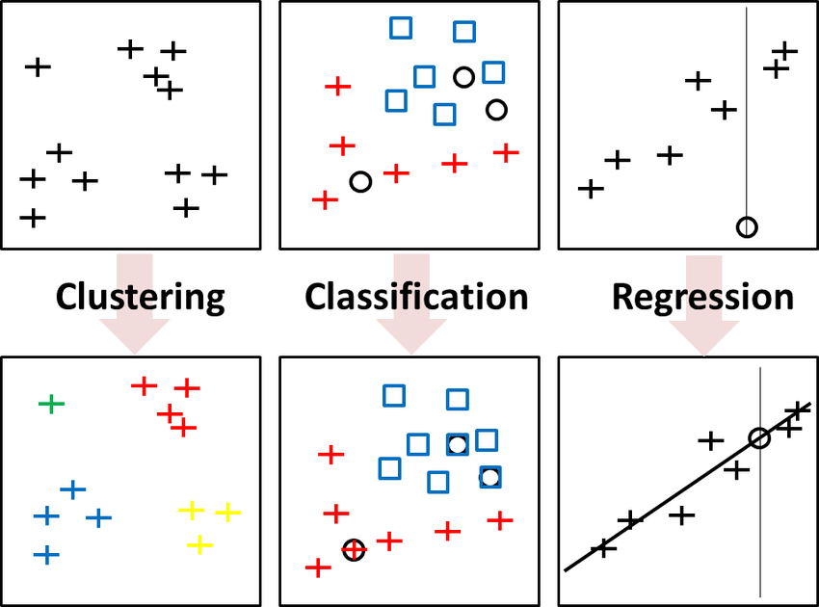

Understanding the difference between classification, regression, and clustering: <https://medium.com/@chandu.bathula16/understanding-classification-regression-and-clustering-in-machine-learning-machine-learning-8b77b4b27c87>

Helpful video: <https://www.youtube.com/watch?v=UE_mfS6G6y4>

Classification/Regression Playgrounds: <https://mlplaygrounds.com/>

Clustering Demo: <https://cartography-playground.gitlab.io/playgrounds/clustering-comparison/>

### In-Class Activity

* In groups of 3, think of 2 different applications for classification, regression, and clustering in real life (6 in total).
* Once complete, each person in your group selects one application and finds a scenario where it is used in a real life application (e.g., using regression to determine stock prices).
* Share your findings with your groupmates

### Applications and Significance

Understanding the applications of these algorithms extends beyond theoretical comprehension, impacting diverse domains. Regression's predictive prowess finds applications in finance, where predicting stock prices relies on understanding market trends and indicators. In healthcare, regression models help forecast patient outcomes based on a multitude of variables.

Classification algorithms safeguard email inboxes from spam, empower recommendation systems on streaming platforms, and fortify security protocols by identifying anomalies. The ability to categorize data into distinct groups, a hallmark of clustering algorithms, is harnessed in customer segmentation for personalized marketing, image segmentation in computer vision, and anomaly detection in fraud prevention.

### Evaluation Metrics and Model Selection

The efficacy of these algorithms is gauged through evaluation metrics tailored to their specific tasks. For regression, metrics like Mean Absolute Error (MAE) and Mean Squared Error (MSE) quantify the model's predictive accuracy. In the classification realm, accuracy, precision, recall, F1-score, and the Area Under the Receiver Operating Characteristic Curve (AUC-ROC) illuminate the algorithm's performance.

Model selection involves a nuanced understanding of the problem at hand and the characteristics of each algorithm. While Linear Regression is adept at predicting continuous values, decision trees shine in scenarios requiring interpretable decision-making. Clustering algorithms, with their capacity to unveil hidden structures, become instrumental when the goal is to uncover patterns within data.

### Challenges and Future Perspectives

The landscape of ML algorithms is not without its challenges. The quest for algorithms that can navigate complex, high-dimensional data while avoiding overfitting remains ongoing. The interplay between interpretability and complexity is a perpetual balancing act, with researchers exploring avenues to enhance model transparency without sacrificing predictive power.

The integration of these algorithms with cutting-edge technologies, including Explainable AI (XAI) and Neural Networks, opens new frontiers. XAI endeavors to demystify the decision-making processes of ML models, providing insights into their inner workings. Neural Networks, inspired by the human brain, push the boundaries of deep learning, enabling algorithms to automatically learn hierarchical representations from data.

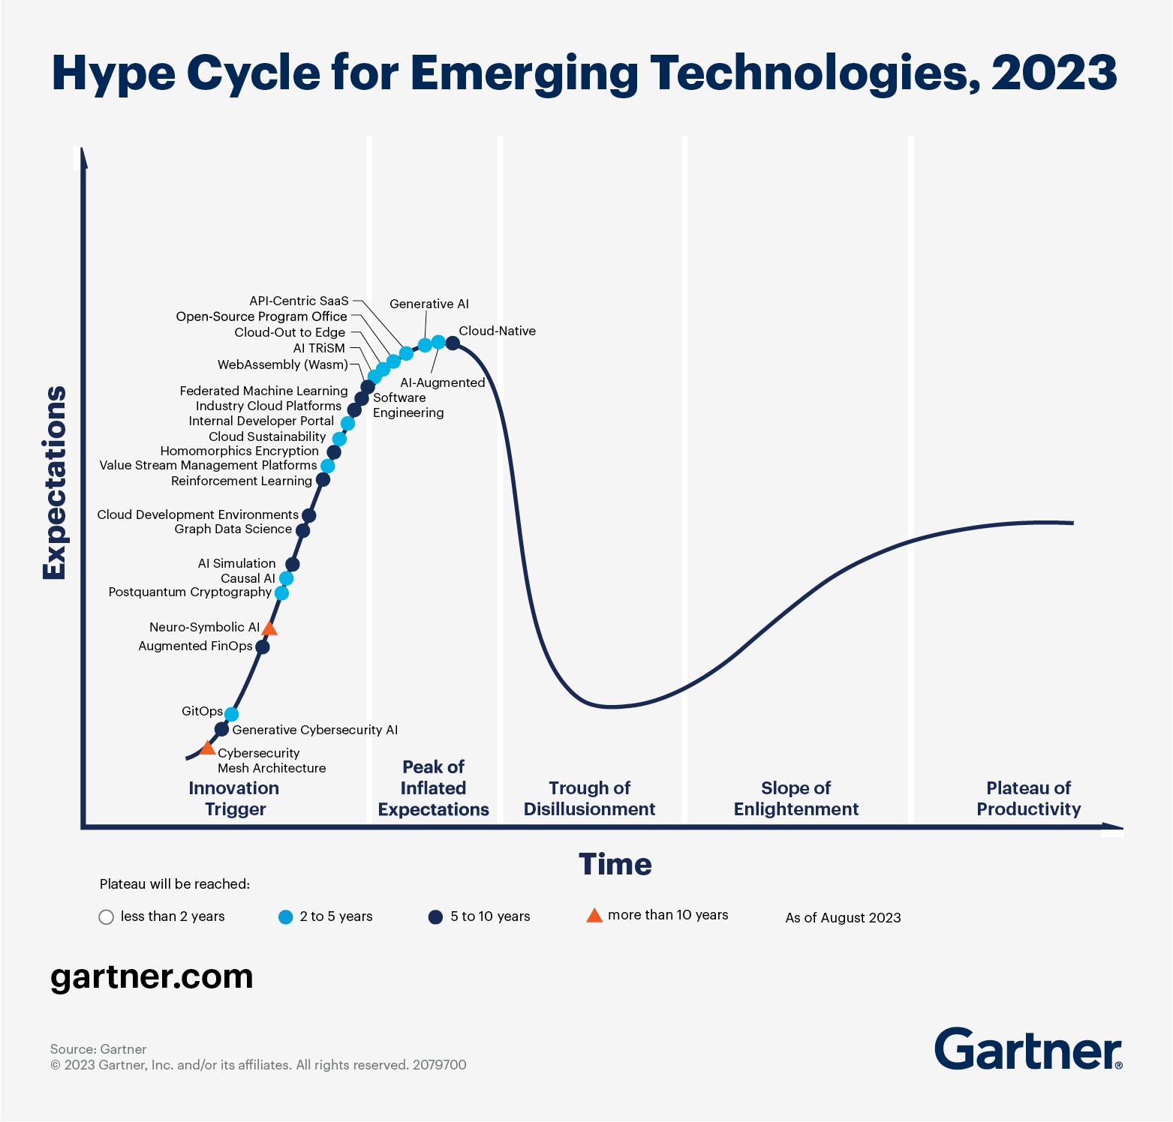

The future of Machine Learning: <https://365datascience.com/trending/future-of-machine-learning/>

### Case Study Analysis (45 mins):

Objective: Analyze a real-world ML case study to understand its approach, challenges, and impact.

#### Activity Steps:

* Group Formation: Form groups of 3. Each group chooses a different ML case study.
* Discussion and Analysis (20 mins): In groups, analyze the case study. Identify the ML technique used, the problem solved, challenges faced, and the solution's impact.
* Group Sharing (10 mins): Each group presents their case study analysis and solutions, followed by a Q&A session.

Case Studies: <https://pub.towardsai.net/7-case-studies-of-data-science-and-ml-on-top-companies-45844ac48d8c>

## Conclusion: Navigating the ML Landscape with Insight and Foresight

In this module, we have covered the fundamental concepts and diverse types of Machine Learning (ML). We began by defining ML and contrasting it with traditional programming, highlighting its reliance on algorithms to learn from data. Our exploration spanned the various types of ML, including Supervised, Unsupervised, and Reinforcement Learning, each with distinct methods and applications. We delved into the practical applications and societal implications of these methodologies, addressing issues such as bias, transparency, and accountability.

Further, we examined the critical aspects of Data Processing in ML, focusing on features, training, testing, and validation. We emphasized the importance of feature engineering, the iterative process of model refinement, and the balancing act between training, testing, and validation. The module also detailed the key algorithms of ML: Regression, Classification, and Clustering, along with their respective applications and significance in fields like finance, healthcare, and marketing.

Throughout, we addressed the challenges and future prospects in ML, including the integration of emerging technologies like Explainable AI (XAI) and Neural Networks. We underscored the importance of evaluation metrics and model selection, considering the nuances of each problem and the characteristics of various algorithms. In conclusion, this module provided a comprehensive understanding of ML's core principles, applications, and ethical considerations, equipping learners with the knowledge to navigate the dynamic and evolving landscape of Machine Learning.